Appendix to PPG Meeting Wednesday 17 June 2026

1. Cyber Security Presentation from Sam Hancock - Cyber Protection -Derbyshire Police

Below is the generic input we deliver to communities – I will also forward the pdf of the bespoke session for your group. Apologies for the delay, still playing catch up. I’m still putting information together re Facebook pages vs groups etc as we don’t have anything already set up with that detail

To secure all of your online accounts, we strongly recommend :

Two Factor Authentication (2FA) aka 2 Step Verification and Multi Factor Authentication
Wherever possible, enable two factor authentication (aka 2SV/MFA) – it’s basically an extra layer of security preventing unauthorised access to online accounts, even if someone manages to obtain your username and passwords. Visit www.2fa.directory for step by step instructions. This is particularly important on email accounts, social media, WhatsApp and shopping/payment accounts. Type in the name of the site/app you have accounts with – if they support 2FA they will show in green and you press the “Document icon” or “Documentation button” to take you to the set up instructions.

Do not save payment details to accounts that do not support 2FA. If your primary email provider does not support 2FA, we very strongly advise setting up a new one.

Protecting your online accounts
Visit www.haveibeenpwned.com – check to see if your details have been compromised in known data breach incidents. Click on the three lines and opt for ‘notify me’ – you will be contacted anytime your passwords are found to available in a new breach, allowing you to immediately change your passwords to protect your online accounts.

Passwords
It’s imperative that we use strong and separate passwords for all online accounts – these ideally are created based on three random words.

In terms of how to manage remembering them all, we advocate :

- Consider using a Password Manager App
- Making a note of usernames and a reminder hint of the password – keep separate from devices
- If you are the only person using your device, you can save passwords to your browser if prompted – bear in mind that anyone using your device would be able to automatically log in to sites you have saved the password for though.

Your most important passwords are the ones to your email account and password manager, if you have one.

More info here https://www.ncsc.gov.uk/cyberaware#action-2

Facebook
Ensure your Facebook account password is strong (three random words) and not used on any other accounts.

Check to ensure your posts are visible only to friends, not public
Control who can see what you share | Facebook Help Centre

It is not uncommon for Facebook accounts to be cloned (duplicated) to trick people into accepting the duplicated friend request.

To prevent this from happening, we strongly advice anyone with a Facebook account change the settings so that your friends list is visible to only you or only to friends

Here’s how :
Who can see the Friends section of my Facebook profile? | Facebook Help Centre

In order to help protect your account from being compromised, we advise that you change your settings to enable two factor authentication to help prevent unauthorised access

Here’s how :
What is two-factor authentication and how does it work on Facebook? | Facebook Help Centre

If your account has been compromised, just changing the password does not necessarily secure your account – it’s important that you review where you are logged in, and on what devices – then log off any you don’t recognise, here’s how :
Log out of Facebook on another computer, phone or tablet | Facebook Help Centre

Link to Social Media Checklists to improve your privacy settings
Social Media Checklists | Safer Internet Centre

Devices
Our first line of defence against cybercrime and fraud quite simply is the devices we use to access internet and email – it’s important to keep devices and apps up to date and install updates as soon as they become available – wherever possible, set to auto-update. Also, ensure that your device is secured by password, PIN or biometric security so others cannot access it.
https://www.ncsc.gov.uk/cyberaware#action-5

Back ups (Cloud)
Make sure your important contact information, and documents are not just saved on your device/Network – make use of back up cloud services so in the event of device failure, loss etc you can still access what is important to you. You may wish to play double safe and also back up to a separate device too.
https://www.ncsc.gov.uk/cyberaware#action-6

Antivirus
Ensure that computers and laptops have antivirus installed and running. Mobiles and tablets don’t need additional AV provided you only downloaded from iStore / Play Store.

Create your own personalised Cyber Action Plan
Learn how to protect yourself or your small business online with the Cyber Aware Action Plan. Answer a few questions on topics like passwords and two-factor authentication, and get a free personalised list of actions that will help you improve your cyber security.

Stay protected online with a Cyber Action Plan - NCSC.GOV.UK

GOLDEN RULE FOR ALL!
Remember NEVER to click a link or shortcut to log in to an account or “resolve and issue” from and email or text message – always log in via a browser or an app.

Did you know ….
You can report suspicious emails by forwarding to report@phishing.gov.uk and suspicious texts to 7726.

Below are the social media accounts we use to keep businesses and the public warned and informed – feel free to give us a follow.

Sign up to Derbyshire Police free Community Email Messaging Service, for local beat information, crime prevention, fraud and cyber advice visit www.derbyshirealert.co.uk and select “Sign up now”.

You are welcome to share this information with others.

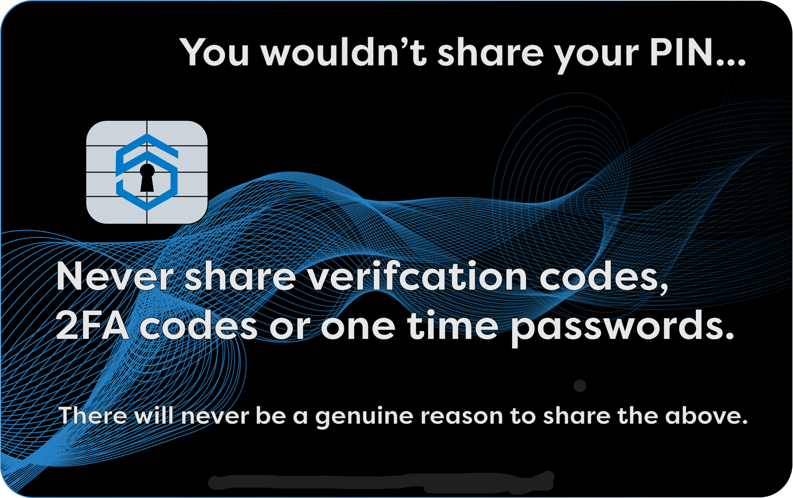

Kind regards
Sam
Samantha HANCOCK
Cyber Protect Officer
Cybercrime Unit – C Block, Force Headquarters
Derbyshire Police
